## 

BATCH CODE: 1607E1

## Our Group Members:

## Syed Muhammad Maaz:

**Submitted To:**

[eprojects@aptech.ac.in](mailto:eprojects@aptech.ac.in)

**Project Instructor:**

**Miss Ansa Tariq**

**Curriculum Code:**

**6624**

## (Student977800)

## Muhammad Zeeshan:

## (Student976392)

## Muneeba Nazim:

## (Student984591)

## Muhammad Hasnain:

## (Student979121)

## Abdul Sabur Ansari :

## (Student959844)

## 

## TABLE OF CONTENT

**Project certification…………………………………………………….5**

**Introduction of Cosy Air-conditioner………………………………6**

**Requirement specification……………………………………………...7**

**Hardware/software requirements…………………………….……8**

**Home page…………………………………………………………………...13**

**About us……………………………………………………………………..…14**

**Brands information……………………………………………………….15**

**Contact us description………………………………….……………….16**



**ACKNOLEDGMENT**

**We are thankful to Almighty, ALLAH that by His grace we have been successful. We also thanks to “MIS ANSA TARIQ”**

**we presenting on Dream Weaver in your hands.**

**This is our First Year Semester E-project. We have tried our best & struggled for a better outlook to come. This project has been developed in Dream Weaver. We choose to make Webpage for Cosy Air-conditioner as a project. We find easy to do coding in Dream Weaver.**

**We earnestly hope that this project will provide all the necessarily information required for the user to fulfill their inspiration. However suggestions for improvement of the project will be thankful received & acknowledge**

**PROJECT CERTIFICATION**

***This is to certify that,***

***xyz (Enrolment #) has successfully designed and developed:***

**Cosy Air-Conditioner**

***Submitted by***

***Aptech computer Education***

***Date of issue:***

**27-Oct-2016**

***Date of submission:***

**26-Nov-2016.**

**INTRODUCTION OF COSY AIR-CONDITIONERHARDWARE&SOFTWARE/REQUIRMENT**

**We are a group of 5 student. We watch all sorts of Air-conditioner in all sorts of countries, then write reports and feature articles about them which are published in a newspaper. This is a fine and privileged occupation, and one to be disclosed with tact. People who do respectable, important jobs don’t like to hear about it.**

**1) The Home Page should be created making use of Frames.**

**2) A Menu should be created which would categorize all the information about the features provided in the Site For e.g. a Menu for Various Brands, a Menu for Features of Air-conditioner etc etc something like that.**

**3) The Shop display should be categorized according to the Brand names of Air-conditioner like if a User wants to see only LG Ac then he click on Some LG Link/button etc and he will see only That Brand Air-conditioner and so on.**

**4) A Products of features of Individual Air-conditioner should be displayed on the Web Page along with the AC but detailed Features should be stored in Individual Word documents which can be downloaded or viewed by the User who wishes to see the same.**

**5) A Brands Web Page should also be there where there is Air-conditioner comparisons done with various models of same brand or various models of various brands.**

**- The Brands information should be provided in Tabular format comparing the features of different Air-conditioner**

**- This Brands would be for 5 Air-conditioner of similar brands and 2 C of different brands for 1 month and then it will change so for the time being the Page should handle the above requirement.**

**6) There should be a “Contact Us” page which will have the Address of the Company which is as follows and the mail address which when clicked will invoke the local mail client from where they can send an email**.

**Hardware:**

* **A minimum computer system that will help you access all the tools in the courses is a Pentium 2.45 or better**
* **256Megabytes of RAM or better**

**Software:**

* **Notepad/HTML editor**
* **Dreamweaver**
* **IE 5.0/ Netscape 6.0**

**PROJECT DURATION**

1. ***Analysis-18 Hrs.***
2. ***Design – 22 Hrs.***
3. ***Development –20Hrs***
4. ***Testing – 12 Hrs***
5. ***Documentation -11 hrs***

**Analysis – Hrs**

**27 Oct TO 26 Nov**

**Documentation-Hrs**

**23 MAYTO23MAY**

**Testing-Hrs**

**21 Nov TO 22 Nov**

## 

**Design-Hrs**

**5Nov TO 8 Nov**

TASK SHEET

|  |  |  |  |  |
| --- | --- | --- | --- | --- |
| **NO.** | **Task** | **Start** | **Finish** | **Resource Names** |
| **1.** | **Analysis** | **27-Octl-16** | **2-Novl-16** | **Syed Maaz, Muneeba Nazim, Muhammad Zeeshan, Muhammad Hasnain, Abdul sabur Ansari.** |
| **2.** | **Research and Planning** | **3- Nov-16** | **7-Nov-16** | **Syed Maaz, Muneeba Nazim, Muhammad Zeeshan, Muhammad Hasnain, Abdul sabur Ansari.** |
| **3.** | **Solution Design** | **8-Nov-16** | **12-Nov-16** | **Syed Maaz, Muneeba Nazim, Muhammad Zeeshan, Muhammad Hasnain, Abdul sabur Ansari.** |
| **4.** | **Development** | **13-Nov-16** | **17-Nov-16** | **Syed Maaz, Muneeba Nazim, Muhammad Zeeshan, Muhammad Hasnain, Abdul sabur Ansari.** |
| **5.** | **Material Searching** | **18-Nov-16** | **20-Nov-16** | **Syed Maaz, Muneeba Nazim, Muhammad Zeeshan, Muhammad Hasnain, Abdul sabur Ansari.** |
| **6.** | **Testing** | **21-Nov-16** | **22-Nov-16** | **Syed Maaz, Muneeba Nazim, Muhammad Zeeshan, Muhammad Hasnain, Abdul sabur Ansari.** |
| **7.** | **Documentation** | **23-Nov-16** | **24-Nov-16** | **Syed Maaz, Muneeba Nazim, Muhammad Zeeshan, Muhammad Hasnain, Abdul sabur Ansari.** |

**LIST OF VALIDATION**

|  |  |
| --- | --- |
| **Option** | **Validation** |
| **Fields in Form should not be Null** | **Yes** |
| **Hyperlinks Have Alternating Text** | **No** |
| **Search Pages** | **Yes** |
| **Homepage Has Forward Only Link** | **Yes** |
| **hAll Web pages have link back to Homepage** | **Yes** |
| **Request Quote Form Included** | **No** |
| **All Functions Are Compatible with Firefox** | **Yes** |
| **All Functions Are Compatible with IE** | **No** |

**SUBMISSION CHECK LIST**

|  |  |  |  |
| --- | --- | --- | --- |
| **No.** | **List of Items** | **Remarks** | **Comments** |
| **1)** | **Do All Pages Linked together** | **Yes** |  |
| **2)** | **Are structure (HTML), presentation (CSS), and behavior (JavaScript) separated** | **Yes** |  |
| **3)** | **Are the links visible** | **Yes** |  |
| **4)** | **Site Browser Compatible** | **No** | **Tested only in Chrome** |
| **5)** | **Feedback Form Included** | **Yes** |  |
| **6)** | **Project Zip File** | **Yes** | **Created using WinRAR** |

**HOME PAGE**

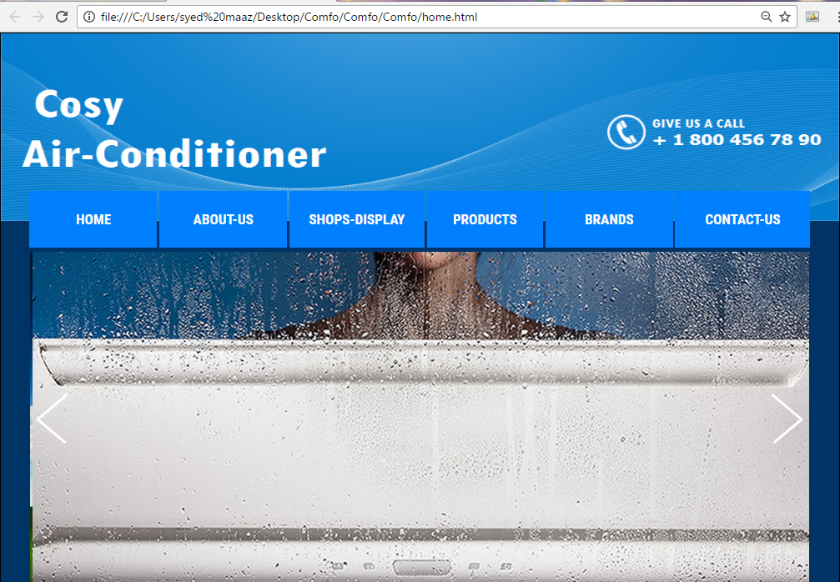

**ABOUT US PAGE**

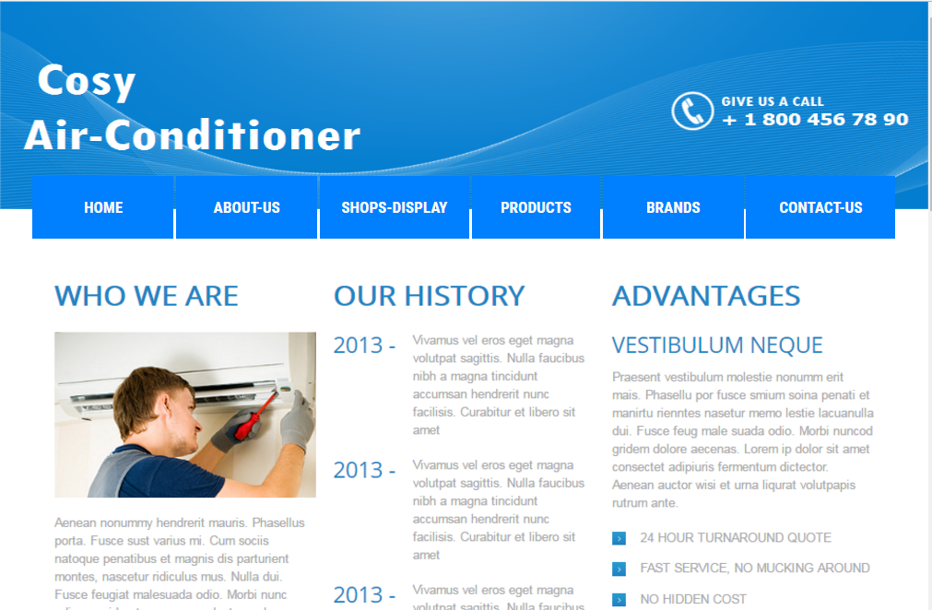

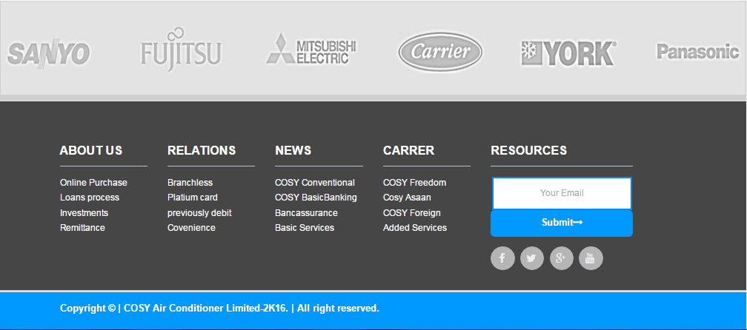

**SHOPS DISPLAY PAGES**

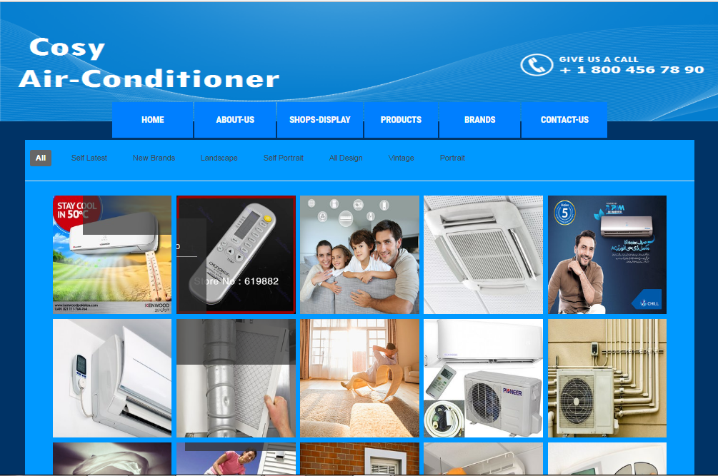

**CONTACT US PAGE**

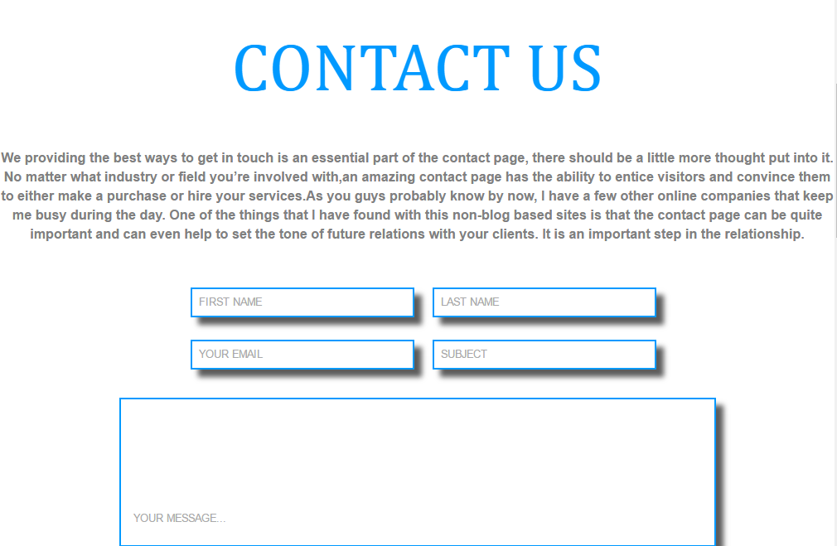

**THANK YOU**

**……….YOUR REGARDS……….**

**“IF YOU ANY PROBLEMS PLEASE CHECK OUR WEBSITES”**